Basics till HTML JS and HTML Forms
- The <!DOCTYPE html> declaration defines that this document is an HTML5 document
- The <html> element is the root element of an HTML page
- The <head> element contains meta information about the HTML page
- The <title> element specifies a title for the HTML page (which is shown in the browser's title bar or in the page's tab)
- The <body> element defines the document's body, and is a container for all the visible contents, such as headings, paragraphs, images, hyperlinks, tables, lists, etc.
- The <h1> element defines a large heading
- The <p> element defines a paragraph
Some HTML elements have no content (like the <br> element). These elements are called empty elements. Empty elements do not have an end tag!
<!DOCTYPE html>
<html>
<head>
<title>Page Title</title>
</head>
<body>
<h1>My First Heading</h1>
<p>My first paragraph.</p>
</body>
</html>
An HTML element is defined by a start tag, some content, and an end tag

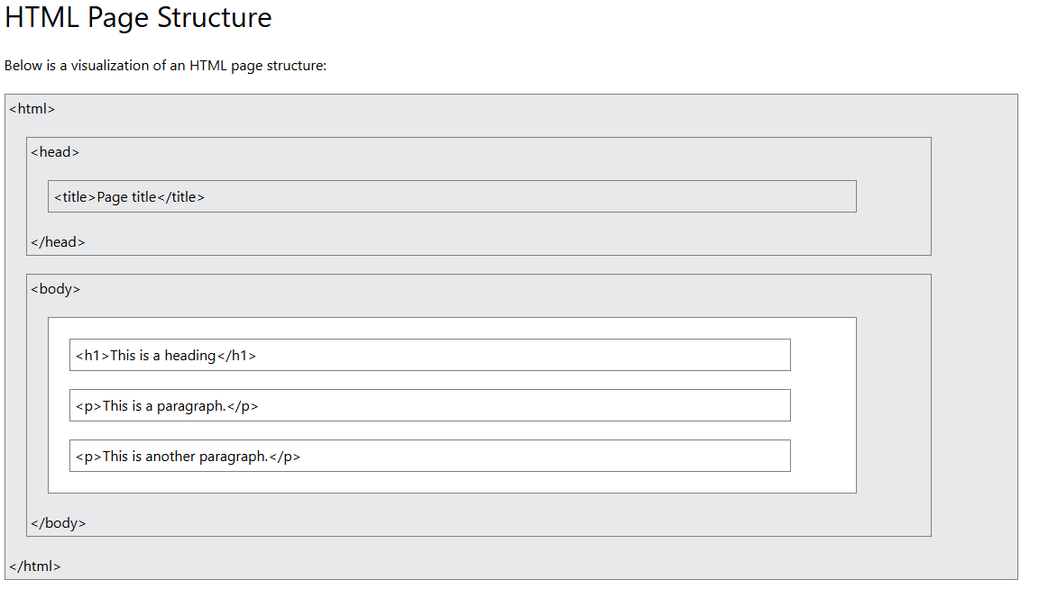

-Use Notepad, save as .html. and then open one web.

